**Password Generator**

**Problem Statement:**

* In today's digital world, maintaining strong and secure passwords is crucial to protect sensitive information and maintain data privacy. However, manually creating complex passwords that are difficult to guess and crack can be a time-consuming and challenging task. This is where a Password Generator comes to the rescue.
* A Password Generator is a powerful tool that automates the process of generating robust and secure passwords. It eliminates the need for users to come up with passwords on their own, ensuring that passwords are random, unique, and meet specific complexity requirements.
* With a Password Generator, users can specify the desired length of the password, including a combination of uppercase and lowercase letters, numbers, and special characters. The generator then uses sophisticated algorithms and logic to generate passwords that are virtually impossible to guess or crack through brute-force attacks.
* The Password Generator saves users from the hassle of remembering multiple passwords for different accounts. By generating unique passwords for each account, it enhances security and minimizes the risk of unauthorized access to personal or sensitive data.
* Not only does a Password Generator simplify the process of password creation, but it also significantly improves the overall security posture of individuals and organizations. By automating the generation of strong passwords, it ensures that security best practices are followed consistently.
* In this presentation, we will explore the implementation of a Password Generator using UiPath, a leading Robotic Process Automation (RPA) platform. We will delve into the workflow, technical details, and benefits of the Password Generator project, showcasing how it empowers users to create secure passwords.

**Activates Used in Bot:**

* **Open Browser:** In UiPath, the "Open Browser" activity is a built-in activity that allows you to launch and interact with a web browser within your automation workflow. It enables you to automate web-based tasks by providing a connection between your UiPath robot and the target web application.

When using the "Open Browser" activity, you need to specify the URL or the web page you want to open. You can also configure additional settings such as browser type (Chrome, Firefox, Internet Explorer, etc.), whether to open the browser in private mode, and whether to maximize the browser window.

* **Type-Into: The** "Type Into" activity in UiPath is used to simulate keystrokes or input text into a target application or text field. It allows you to automate the process of entering data into various types of user interfaces, such as web pages, desktop applications, or terminal windows.

When using the "Type Into" activity, you need to provide the following inputs:

* Target: The target UI element or text field where you want to input the text. You can indicate the target element by using selectors or by indicating it directly on the screen.
* Text: The text you want to enter the target element. You can provide a static text value or a variable containing the text you want to input.
* DelayBetweenKeys (optional): This field allows you to specify the delay (in milliseconds) between each keystroke. It can be used to simulate human-like typing speed and to accommodate slower systems or applications.
* ClickBeforeTyping (optional): If enabled, this checkbox indicates whether the target element should be clicked before typing. It can be useful in cases where the element requires focus or activation before accepting input.
* By providing these inputs, the "Type Into" activity will simulate keystrokes to input the specified text into the target element. It supports typing alphanumeric characters, special symbols, and control keys like Enter, Tab, or Backspace.

The "Type Into" activity is commonly used in data entry automation, form filling, or any scenario where you need to input text into applications or text fields. It helps automate repetitive typing tasks and improves the accuracy and efficiency of your automation workflows.

**Click:** Used to click on the elements for the clicking the elements you want to enter in website.

**Get-Text:** It is used to extract the text over anywhere from the website.

**Message box:**

* A message box, sometimes referred to as a dialog box or alert box, is a graphical user interface (GUI) element used to display important messages, notifications, warnings, or prompts to users in software applications. It typically appears as a small window that interrupts the normal flow of the application to deliver the message.
* A message box usually contains a brief message accompanied by buttons or options for the user to choose from, such as "OK," "Cancel," "Yes," "No," or "Retry." The buttons allow users to provide a response or take appropriate action based on the message displayed.

The main purposes of a message box are:

1. Displaying information: It can be used to provide important information or notifications to users. For example, it can show a success message after a task is completed or display an error message when an error occurs.
2. Seeking user input: Message boxes can be used to prompt users for input by presenting them with options or asking them to make a choice. This can be useful when confirming an action, requesting confirmation for deletion, or seeking user preferences.
3. Displaying warnings or errors: Message boxes are commonly used to alert users about warnings, errors, or exceptions that have occurred during the execution of an application. They help communicate issues and guide users on how to proceed.

**Excel scope:**

* In UiPath, the "Excel Scope" activity is a container activity that allows you to perform a series of Excel-related operations within a specified Excel application or workbook. It establishes a connection to an Excel application and provides a scope within which you can execute various Excel-related activities.
* When using the "Excel Scope" activity, you need to specify the Excel file or workbook you want to work with. You can provide the file path or use other activities to dynamically retrieve the file location. The activity establishes a connection to the Excel application or workbook and ensures that subsequent Excel activities within the scope are executed in the context of that specific Excel instance.

**Write range:** The "Write Range" activity in UiPath is used to write data from a DataTable or Excel range to a specified Excel file or worksheet. It allows you to automate the process of populating or updating data in Excel.

**Step by step process:**

**To create a bot in UiPath that a password would generate for you can for this follow these step-by-step instructions:**

**1. Open UiPath Studio and create a new project.**

**2. Drag and drop a Sequence activity into the workflow.**

**3. Inside the sequence, add the open browser and enter the website** <https://delinea.com/resources/password-generator-it-tool>.

4. After that add the option to data scraping.

5. After adding type into activity we have to enter the specific data to be targeted like the symbols and size of the password.

6. Then use the click activity on the “generate password” option.

7. Use the get text activity to extract the password from the browser.

8. Make it save a character “password”.

9. Add the activity name to the message box.

10. Make it display the above character password to display the password generated by the website.

11. Use Excel Scope activity.

12. Make an excel file name password to store the password that is generated by the website.

13. Use the write cell activity.

14. Give the cell location to store the password.

How to do:

**

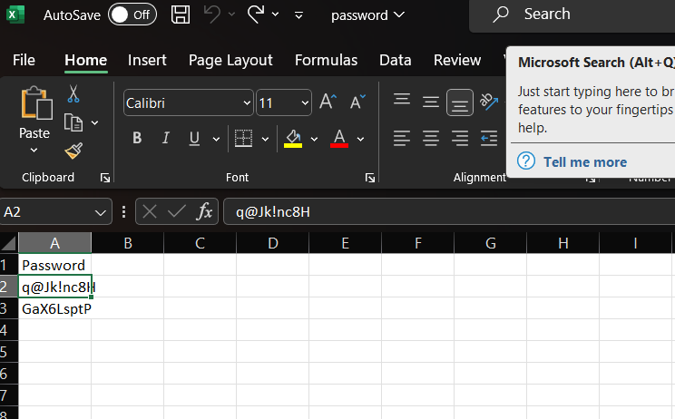

**References:**

* **All the activities used were taught by our teacher Ms. Vani Malagar.**
* **Information from Official Ui Path Website** [**https://www.uipath.com/**](https://www.uipath.com/) **.**
* **All the practicals were performed in the lab.**